S

Space Park

Mid-term Assignment

University of London

Web Development- CM1040

Team 17 (Tutor Group 2)

Dec 31, 2019

Table of Contents

Purpose of the Website 2

Reasons for a theme park operator to have a website: 2

People who might look at such a website: 2

Reasons People would look at a theme park website: 2

Theme Park Websites Research 3

Europa Park 3

Gold-Reef-City 3

Wild Reserve Singapore 4

Alton Towers 4

Beto Carrero 5

Contents for the Website 6

Target Group: 6

Specialisation: 6

Potential Pages: 6

Structure of the Website 7

Agreement on Name: 7

Agreement on Target Audience: 7

Agreement on the Contents: 7

Wireframe Design for the Website 8

Initial Desktop Wireframes 9

Initial Mobile Wireframes 12

Final Desktop Wireframes 15

Final Mobile Wireframes 19

Website Mockups 22

# Purpose of the Website

*Criteria: Discuss the reasons for a theme park operator to have a web site, the people who might look at such a web site and the reasons that they would be looking at the web site.*

### Reasons for a theme park operator to have a website:

* show ticket prices and promotions
* promote and sell tickets
* to reach a wider target audience
* extra revenue revenue from partner advertisements (eg: nearby hotels, food places)
* to show opening/ closing times, park open and closed days, display working times and days during public holidays
* show off attractions, shops and restaurants within the park
* promote and even sell merchandises (eg: t-shirts, souvenirs)
* show contact information and social media links
* show park address

### People who might look at such a website:

* Kids
* Parents and guardians
* School even coordinators
* Event organisers

### Reasons People would look at a theme park website:

* Compare ticket prices with other theme parks
* Purchase tickets
* To look up opening and closing times and days
* To research on types of available rides
* To organise family trips
* Purchase gift merchandises and tickets,
* Estimate total costs (entry, food)
* Find attractions
* Locate on map before travelling and to plan parking options
* Find overnight stays (eg: hotel, bed & breakfast)
* Find target demographics
* Find weather of the area
* Find safety instructions and warnings

# Theme Park Websites Research

*Criteria: As a group, choose five different web sites of theme parks. Review the type of information that you find on the sites, and the structure that these sites have to help people find that information. Make a list of the aspects of the sites that you think are a good idea or that work well, and a list of the aspects of the sites that you don't think are so successful. This will give you some insights that you can use when designing your own website. Keep a record of the discussion in a document.*

### Europa Park

<https://www.europapark.de/en>

*Contributer: Marina Enadeghe*

|  |  |
| --- | --- |
| **Positive Aspects** | **Negative Aspects** |
| * Well structured site * Easy to understand design for all age groups * Prominent display of special attractions * Call to action buttons are prominent, yet not too aggressive * Compact overview of the site in the footer section * Pictures with people and attractions shows a taste of what is waiting for visitors | * Hard to find specific detailed information on rides and attractions * Long list of price with one too many combinations and possibilities |

### Gold-Reef-City

<https://www.tsogosun.com/gold-reef-city-casino/theme-park>

*Contributer: Marlene Mhangami*

|  |  |
| --- | --- |
| **Positive Aspects** | **Negative Aspects** |
| * Simple and easy to find what you are looking for * Weather info at the top of the page * Plenty of attractive pictures * Map downloadable by users * Easy and clear to locate Call to Action buttons | * Too serious of a site, meant to target children * Game and Theatre links are out of place * Header and Footer are not responsive |

### Wild Reserve Singapore

<https://www.wrs.com.sg/en/night-safari.html>

*Contributer: Marc David*

|  |  |
| --- | --- |
| **Positive Aspects** | **Negative Aspects** |
| * The website has a clear structure and is easy to navigate using the bar at the top. Main events and attractions visible on the landing page and social media links embedded. * Same design and layout throughout the entire web site. * Tickets can be easily purchased, the process seems very straightforward. There is a large variety of options, but they are well explained. * Colors, font and picture selection support content. | * The pages which are listed under the menu tab “Learning with Us” could be put together with the ones listed under the tab “Plan your visit”. * A text box showing the opening hours and the address of the theme park is placed at the bottom of the page, however this information should be placed at the top of the page, in my opinion. * Got lost on a subpage and couldn‘t easily get back to the main page. * There seems to be a slider, it isn’t one. |

Conclusion:

All in all, the content of the site is well put together, nevertheless, some information could be bundled together and a few pages seem redundant/repetitive.

### Alton Towers

<https://altontowers.com>

*Contributer: Mathew George*

|  |  |
| --- | --- |
| **Positive Aspects** | **Negative Aspects** |
| * On menu hover, all subcategories will show up. Saves you multiple click to the final destination * Prominent park opening and closing times on view on a banner on the top, under the menu * Seasonal website theme and background images * Well structured and detailed footer area | * Too busy and cluttered pages, overfilled with information * Search button is tiny and is hidden away at the top right corner of the page * No address location is provided in the main page or any obvious pages * ‘Buy Ticket’ area sticks to the bottom of the page and cannot be closed or hidden away, taking up a lot of space |

### Beto Carrero

<https://www.betocarrero.com.br/en>

*Contributer: Tomas Guitierrez*

|  |  |
| --- | --- |
| **Positive Aspects** | **Negative Aspects** |
| * Easy access to sales center * You can easily check whether there are tickets to buy for the planned day * Footer with relevant information and site map | * As a Brazilian website, the English version of the website does not translate everything. This makes it impractical for a foreign to navigate. * No search area, which can be needed |

*Five theme park websites were chosen and discussed upon, during a one hour team Slack call on Oct 29, 2019.*

# Contents for the Website

*Criteria: Agree within the group the theme for your theme park and the types of attractions that you will have for the different visitors that you expect to come to your theme park. Think of any other services that you will provide to visitors (for example food, access to money and medical help). Think of any other information that people looking at your web site will want to know before they come and visit your theme park. Keep a record of the discussion in a document.*

### Target Group:

* teenagers (12 and above)
* adults
* all kind

### Specialisation:

* fairy, pixie, fairytales
* witches, Halloween, horror
* water, bubbles
* typical roller coaster, eg. like on a annual fair
* countries (eg. Europa Park)
* Marvel (problem: pictures / copyrights)
* Safari
* general comics
* *Space theme (picked as the park’s theme, on popular vote)

*science for dummies as something to keep in mind for marketing

### Potential Pages:

* welcome
* attractions
* prices/tickets (book tickets)
* hotel
* partner?
* food (restaurant, special offers, fast food,...)
* shows or movie?
* Contact information and adress

# Structure of the Website

*Criteria: Agree within your group the structure of your web site, with the aim of designing a web site with 3 pages. What information will appear on the main page, and what will appear on the other two pages? Think about how you might present the content, and whether you will have semantic parts such as asides or pop-up windows. Keep a record of the discussion in a document.*

### Agreement on Name:

* Space Park

### Agreement on Target Audience:

* teenagers (12 and above)
* adults

(science for dummies as something to keep in mind for marketing)

### Agreement on the Contents:

1. Landing page
   * Slideshow animation
   * Main Attractions heading (h1)
   * Three main attraction images, each with anchor links underneath
   * Aside area for buttons
   * Sub heading (h2) for map
   * Directions/ map to the park
2. Sub Page 1 (Attractions)
   * Main image
   * Main Attraction Heading (h1)
   * 3 Sub headings
     + Ticket Price info (h2)
     + Photo (h2)
     + Similar Attractions (h2)
3. Sub Page 2 (Tickets)
   * Purchase Tickets heading (h1)
   * Ticket Options heading (h2)
   * Three option names (h3), each with Information (h4), Pricing (h4) and a pricing table (table)
   * Date Selection (h2), Quantity (h2), Checkout (h2)
   * Payment Details (h3)

# Wireframe Design for the Website

*Criteria: Produce a set of wireframes for the site, showing the concepts for both a widescreen and small screen. These can either be drawn by hand or produced using a tool such as PowerPoint or a graphics package such as Illustrator. Avoid painting or photo-editing software such as Paint or Photoshop as designs produced in this way are difficult to edit. Ensure that the designs are clear and easy to read.*

*Wireframe set picked on popular vote from submissions from all members within the group*.

Inital Wireframe Designs

### Initial Desktop Wireframes

1. Desktop Attraction Page

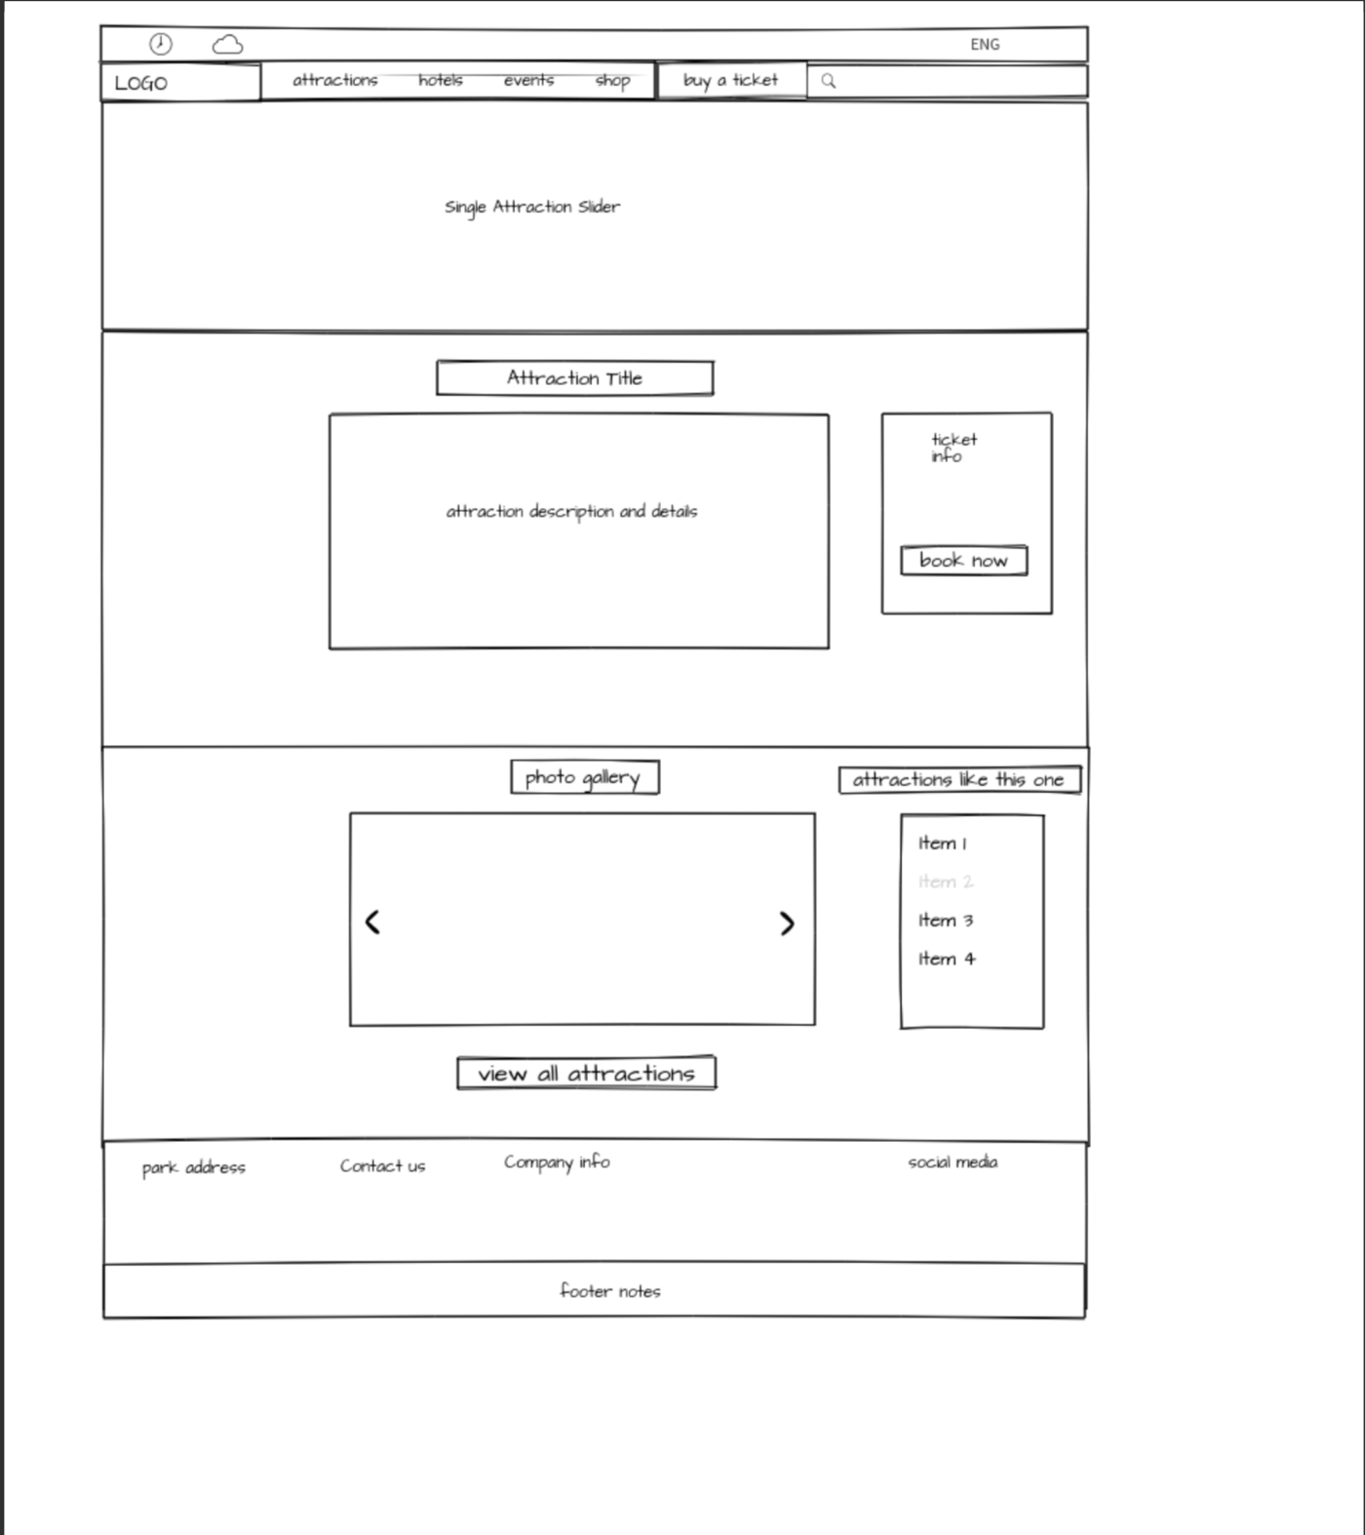

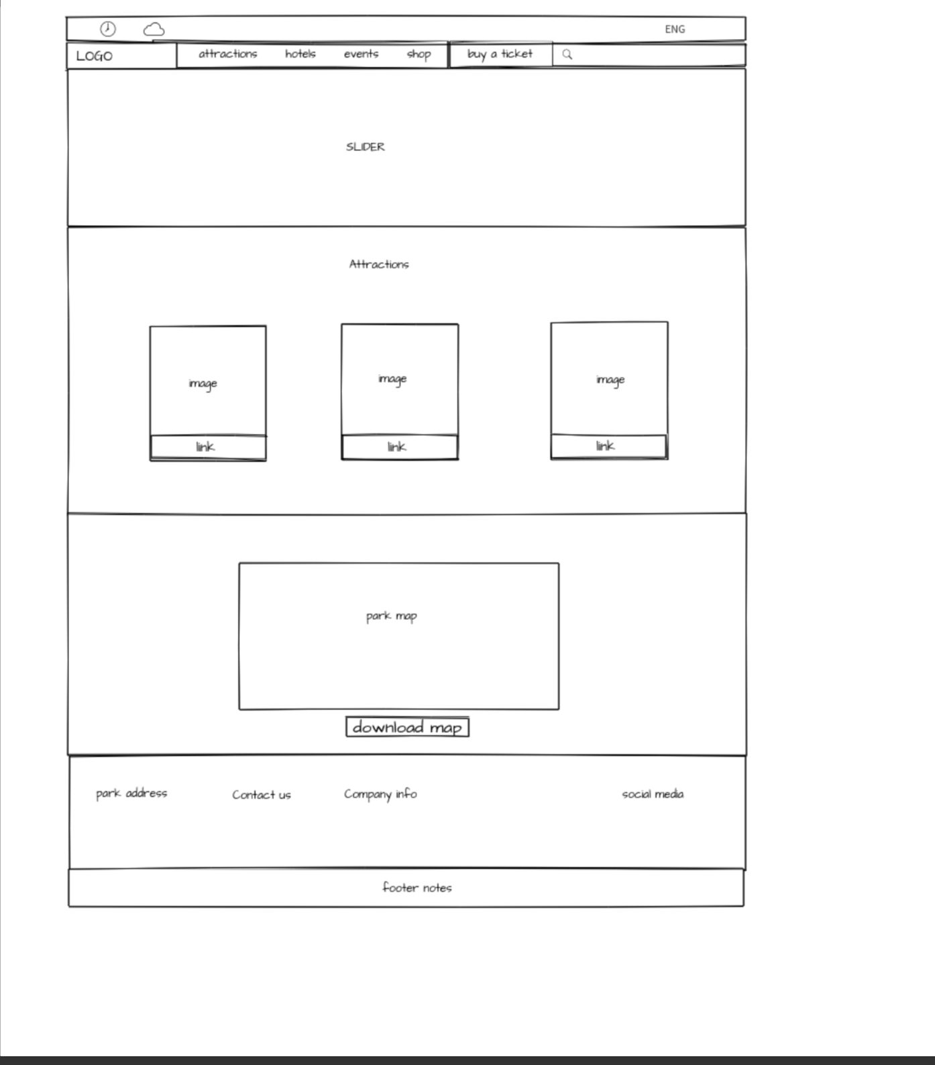

1. Desktop Landing Page

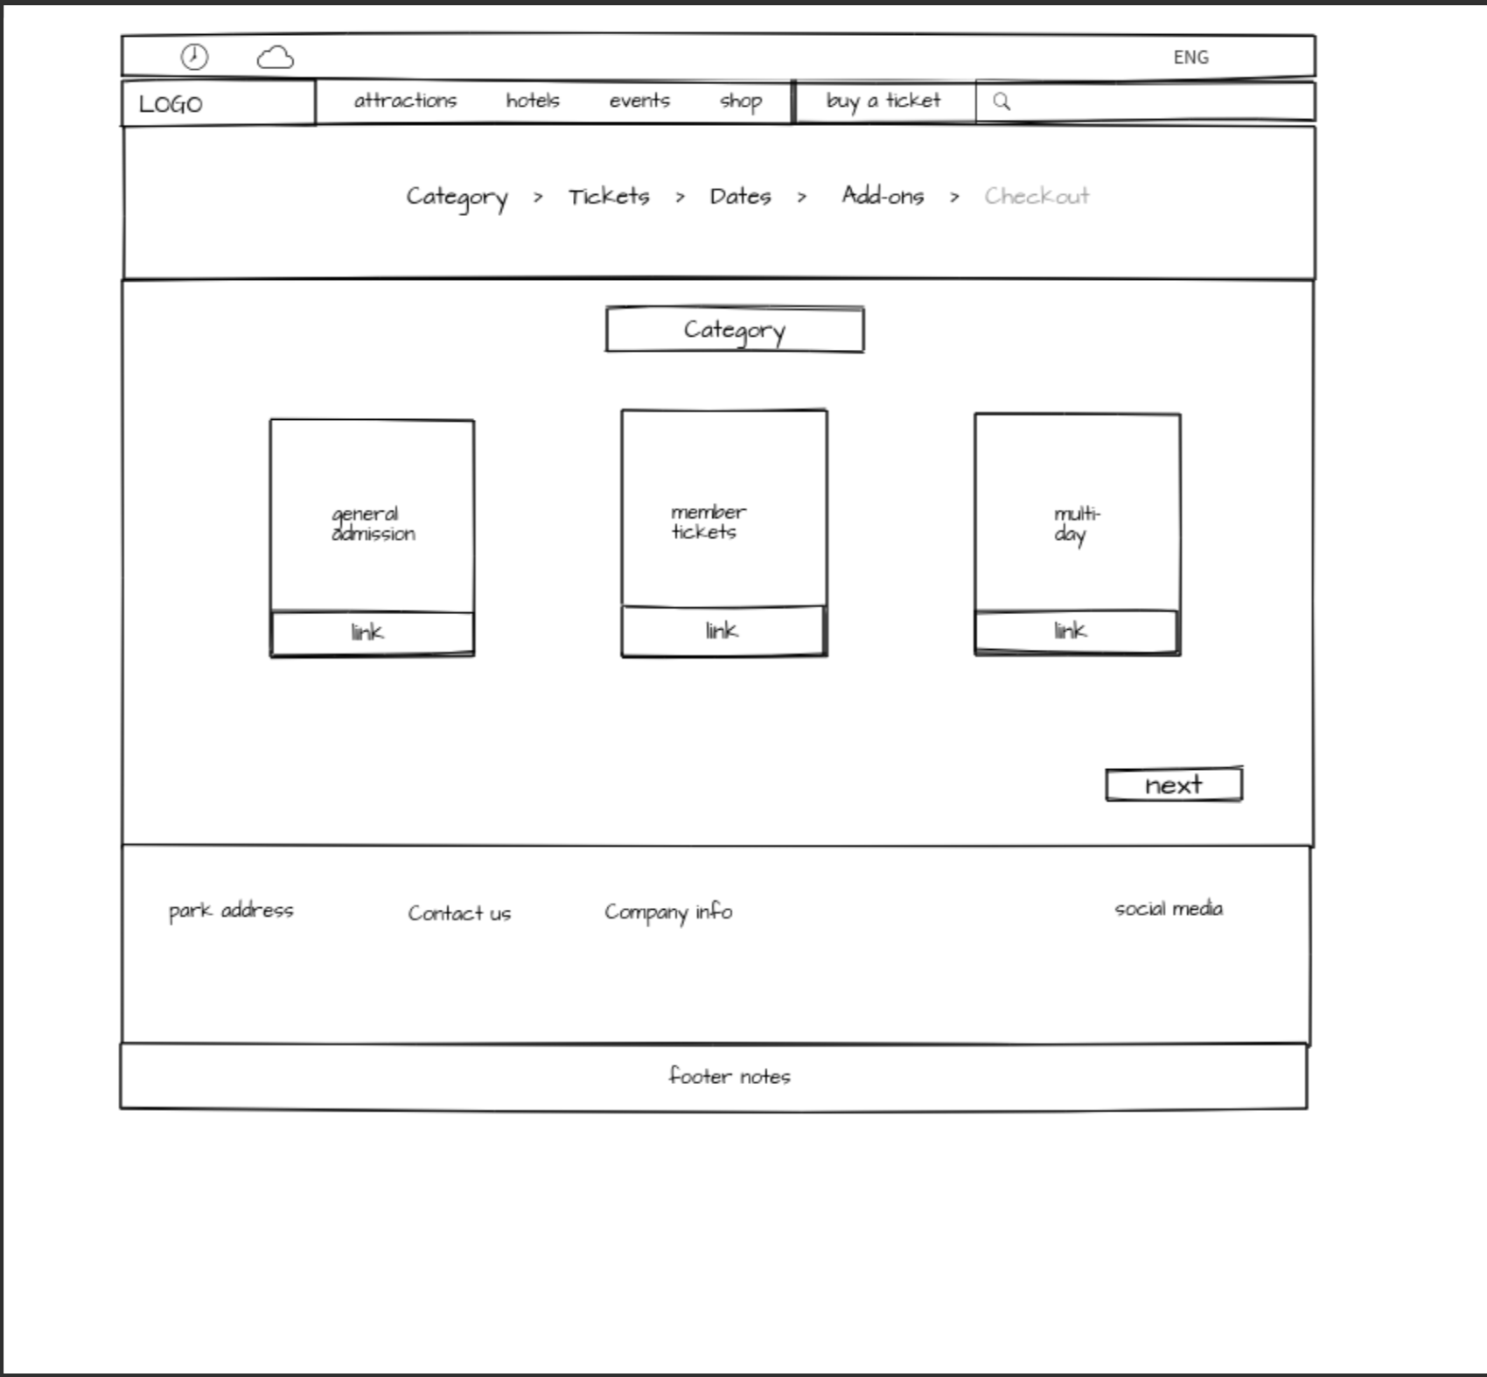

. Desktop Tickets' Page

### Initial Mobile Wireframes

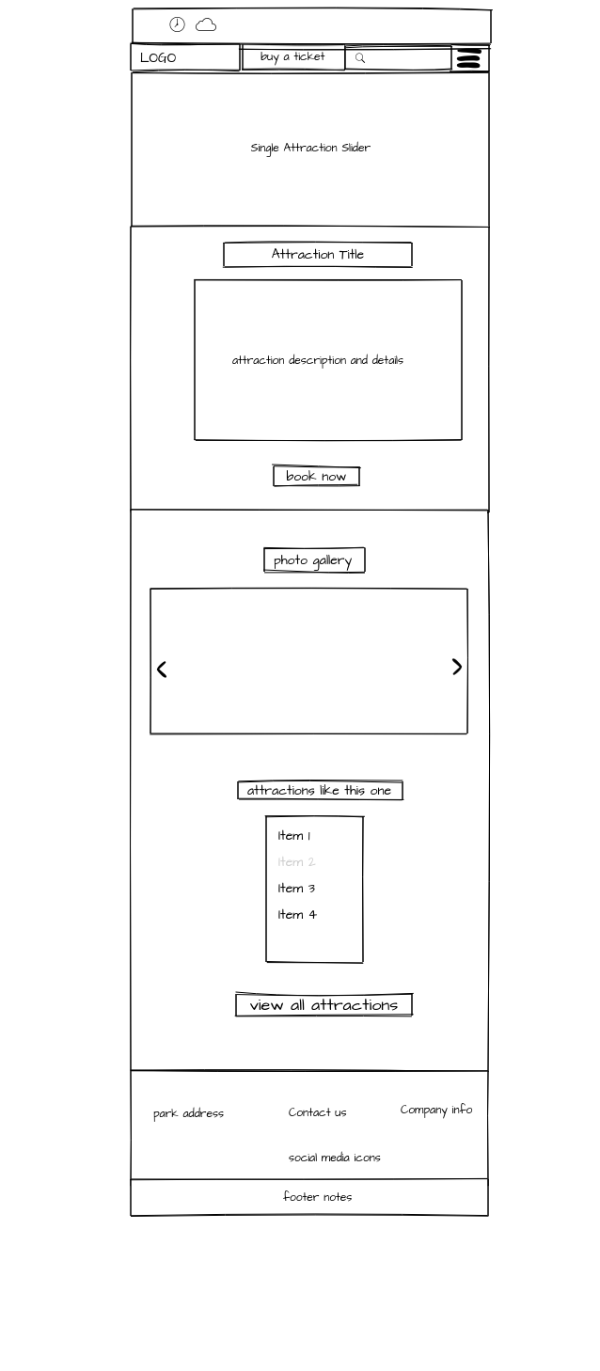

. Mobiel Attraction Page

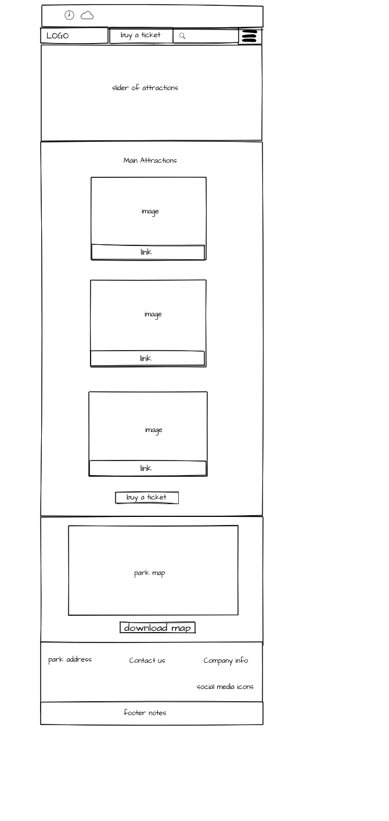

. Mobile Landing Page

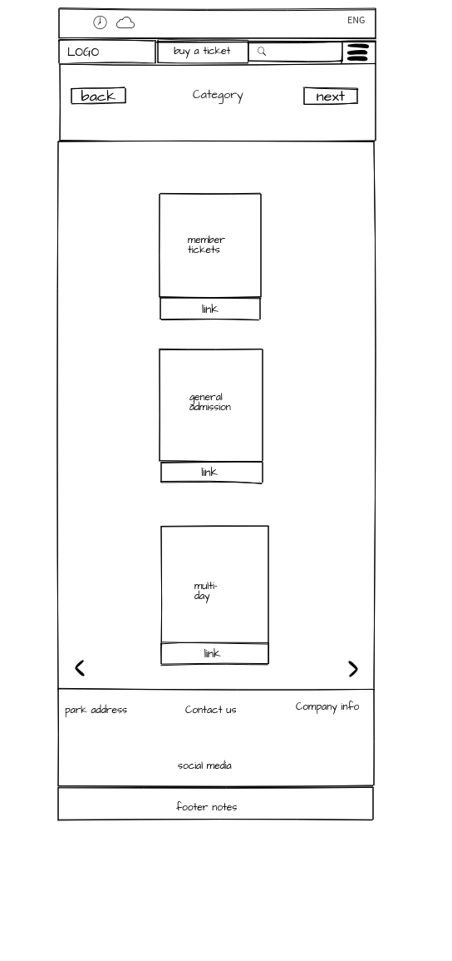

. Mobile Tickets' Page

Final Wireframe Designs

### Final Desktop Wireframes

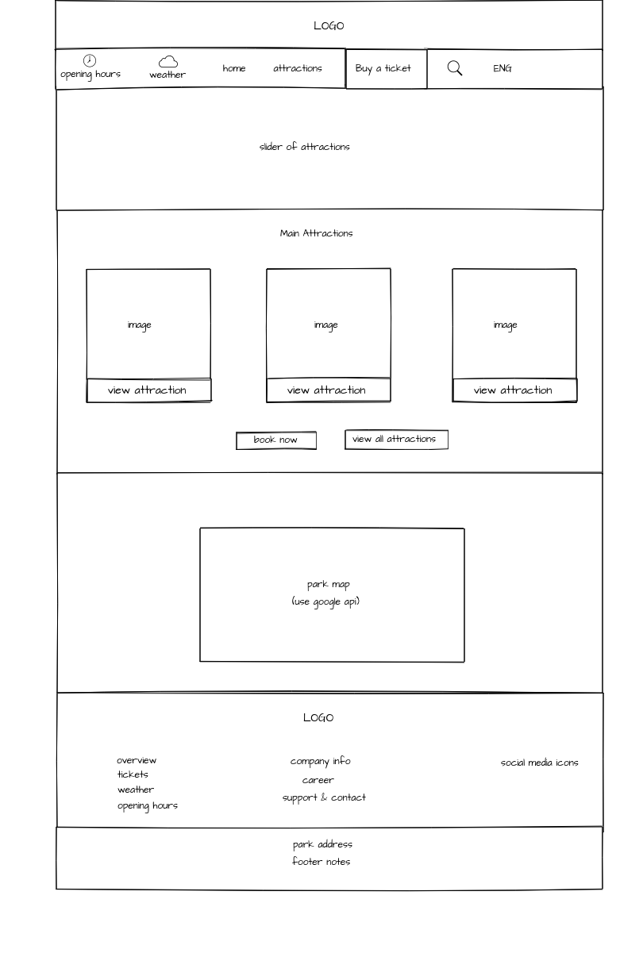

7. Desktop Landing Page

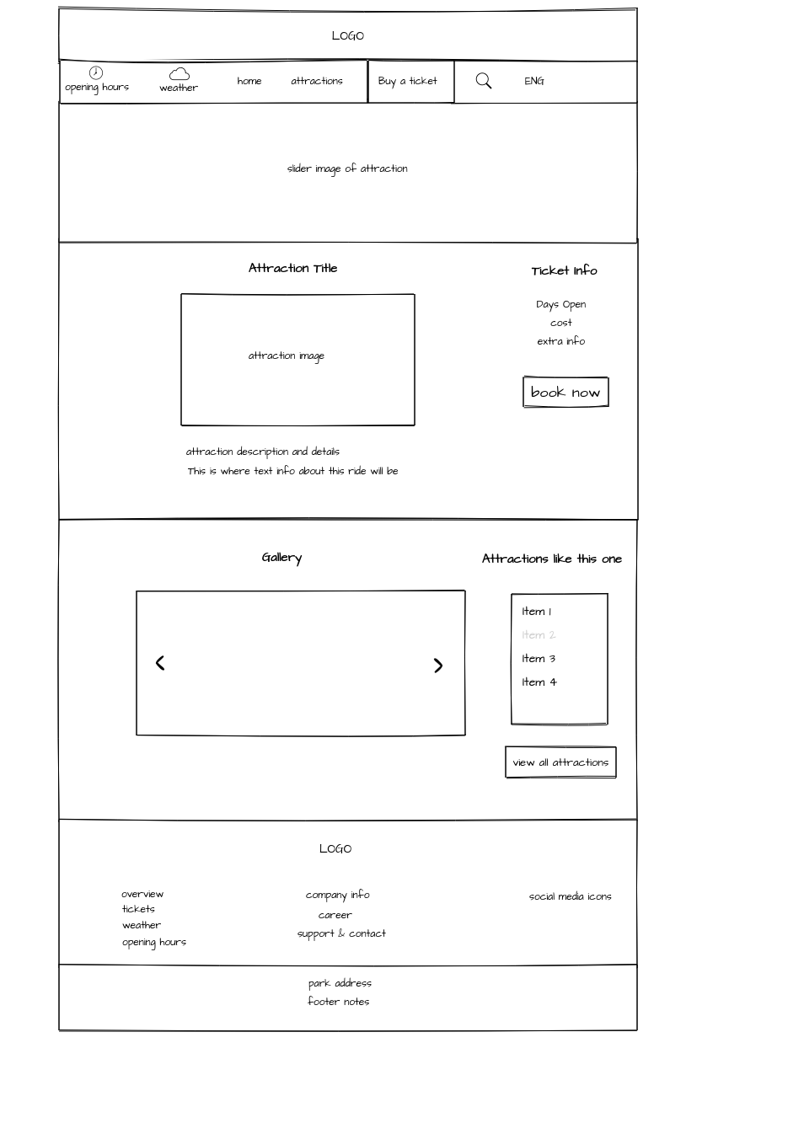

8. Desktop Attraction Page

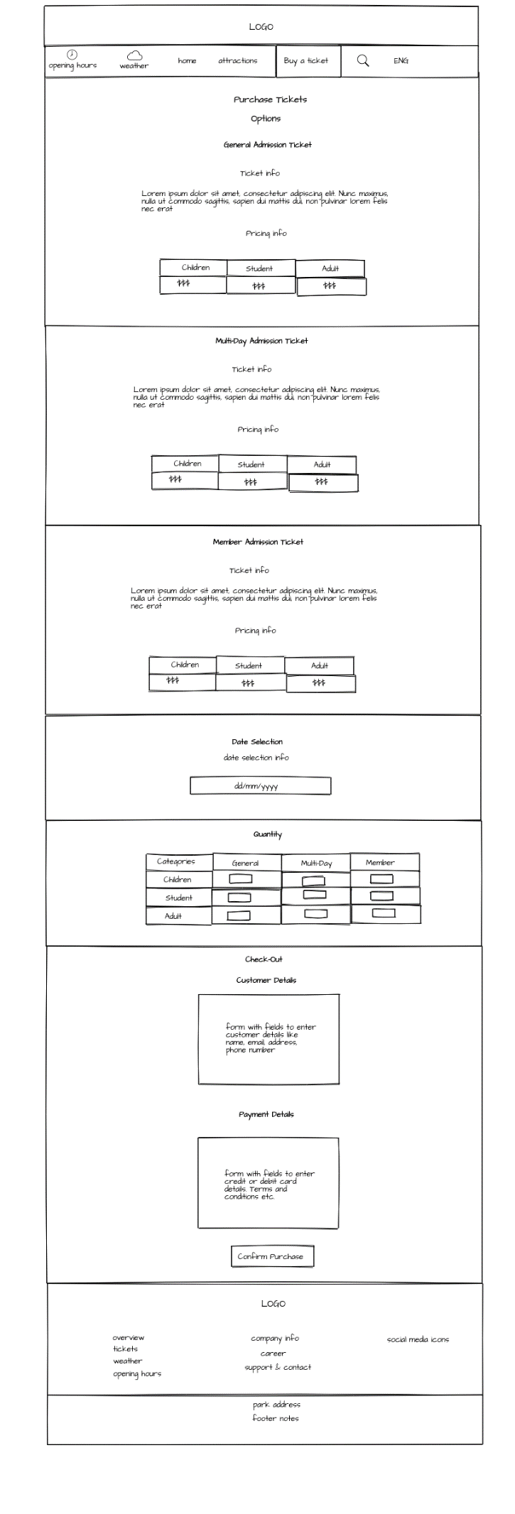

9. Desktop Tickets‘ Page- Part 1

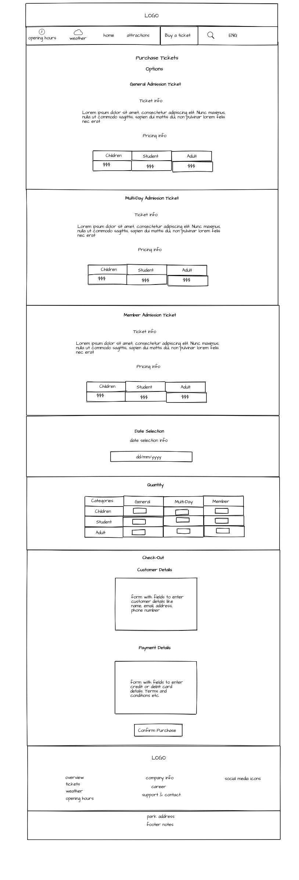

10. Desktop Tickets‘ Page- Part 2

### Final Mobile Wireframes

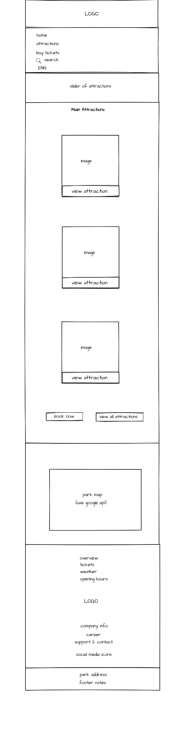

11. Mobile Landing Page



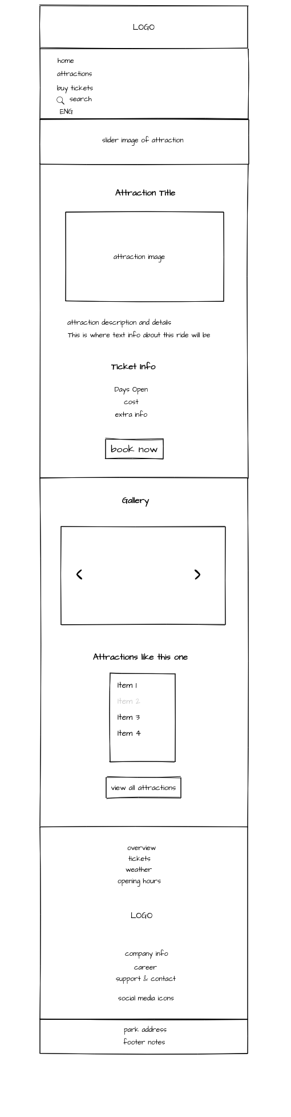

12. Mobile Attractions‘ Page



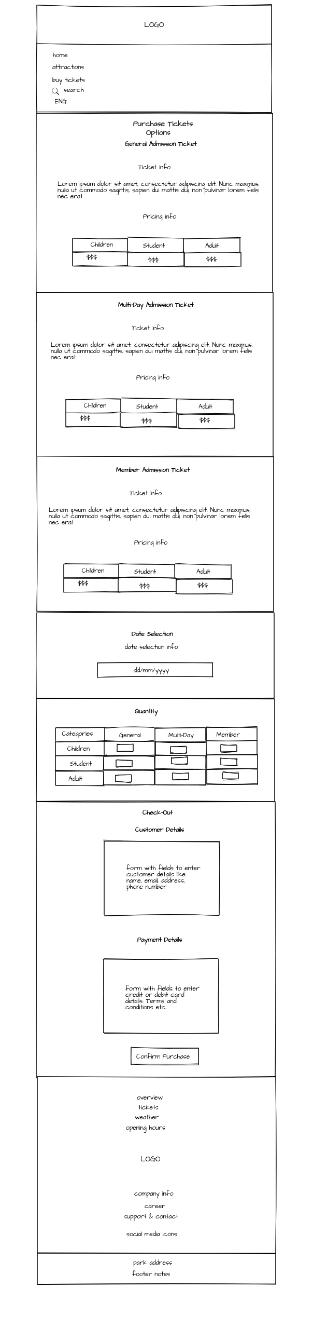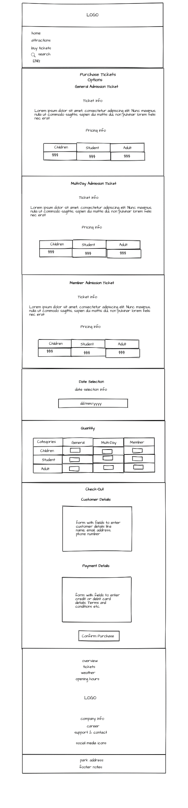

13. Mobile Tickets‘ Page

# Website Mockups

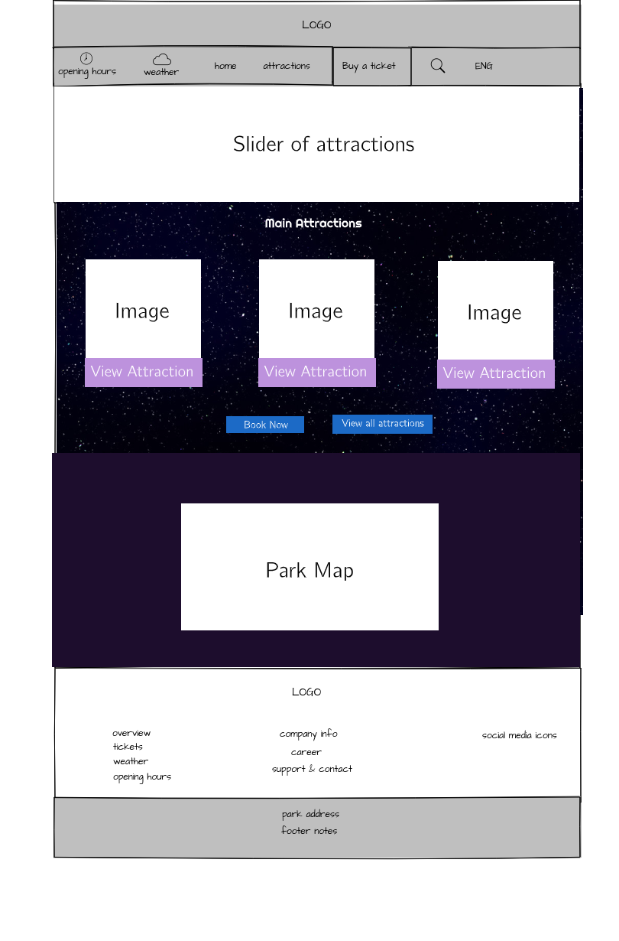

14. Landing Page Mockup

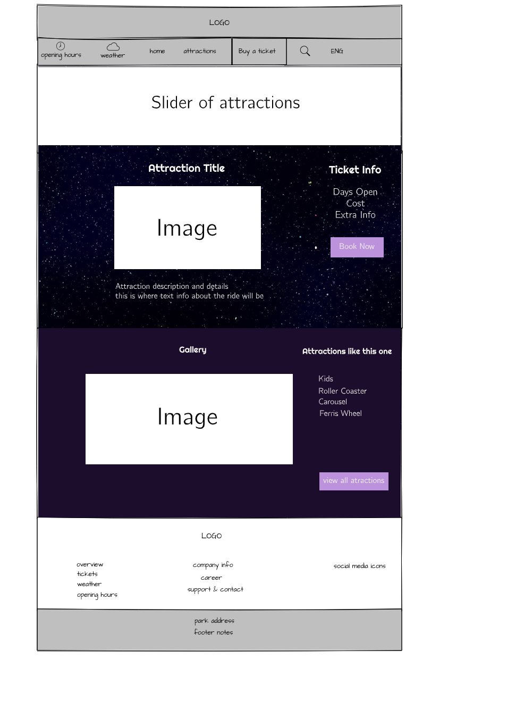

15. Attractions‘ Page Mockup

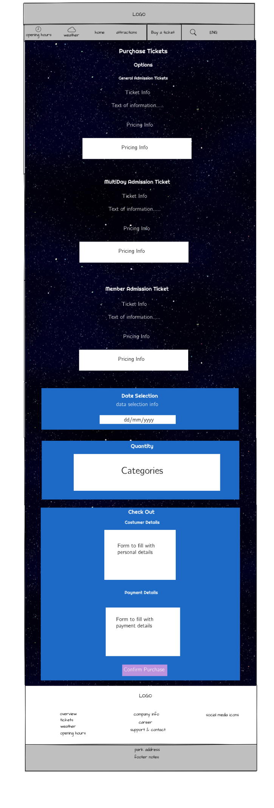

16. Tickets‘ Page Mockup - Part 1

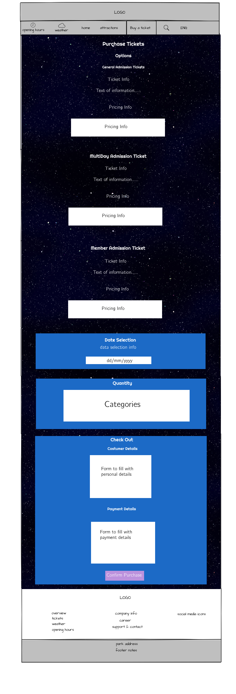

17. Tickets‘ Page Mockup – Part 2